Task 1: Framing the Business Scenario
Example Answer
Great work! Take a look at the example answer below to see how a professional would have attempted this task. Think about what you did well and how you can improve.

Questions of interest to the CEO
Which region is generating the highest revenue, and which region is generating the lowest?
This question is important to the CEO as it is based on the fundamental source of income for the business, i.e., revenue. Revenue analysis is important to the CEO as top-level executives are always focused on earnings and how to increase it. Here, the CEO is interested in the viewing revenue by the regions, to assess which regions are generating the highest revenue and which regions are generating lower revenue. Using the data and
analysis, the CEO will be able to decide on how to further generate revenue in the regions that are already generating the most revenue. For the regions that are not generating enough revenue, the CEO will then study the reasons why there is a lack of sales in those regions and try to improve the products and make them more suitable for those regions.
What is the monthly trend of revenue, which months have faced the biggest increase/decrease?
A monthly trend of revenue will provide the CEO with insights on how the revenue is fluctuating each month. This will enable the CEO to analyze how the internal changes inside the company have had impact on the sales. E.g., how a new product launch has led to an increase in revenue during the month or how the introduction of a new region has led to an increase in revenue for the online store. The CEO can also analyze if there have been any delays internally that would have caused a potential decrease. Such analysis is vital for the senior management as it would enable them to plan ahead and try to make the customer experience as smooth as possible.
Which months generated the most revenue? Is there a seasonality in sales?
In retail businesses, there are always months that will have a greater demand due to seasonality. There will be cases where the data will experience regular and predictable changes that recur every calendar year. Such seasonal months would be necessary to identify as the CEO would be interested in devising a strategy that would gain the maximum benefit from the months that have greater demands.
Who are the top customers and how much do they contribute to the total revenue? Is the business dependent on these customers or is the customer base diversified?
This analysis is highly important as it would enable the CEO to identify what the main drivers are behind the total revenue. Looking at the top customers of the retail store would provide an idea of which customers are
contributing the most to the revenue. The store can then derive a strategy where the top customers can be targeted with more products that they can buy. This will ensure higher revenue for the store as these customers
are the top buyers from the store. Although having fewer customers buying in high volumes can be beneficial for a business, there can also be a drawback. Retailers would have less bargaining power with these customers because they drive the majority of the revenue for the store and can negotiate lower prices. The CEO needs to be notified of the diversification of the customers so that he can plan ahead of time. In cases wehre the business is highly dependent on a few customers, the plan would be to increase the customer base and target more customers that would bring more revenue to the store.

Questions of interest to the CMO
What is the percentage of customers who are repeating their orders? Are they ordering the same products or different?
This question shows that the CMO is interested in viewing the trends in customer orders. He is interested to know how many customers out of the total are coming back to them and re-ordering. This analysis will help explain to the CMO what percentage of customers are buying from them more than once. Once this is identified, the CMO can come up with a strategy to target these customers with more offers and products that they would need. The analysis will also be done to see what they are buying the second time, this will provide the CMO trends into what products and sub products are in demand and then a marketing strategy can be devised to target these customers with better options.
For the repeat customers, how long does it take for them to place the next order after being delivered the previous one?
This analysis will help the CMO identify the frequency of orders. This would mean determining how long the customers are taking to re-order from the store. The expectation is that those customers who have recently made a purchase would have the product on their mind and are expected to purchase or use the product again in the future. Once the information is gathered from the analysis, the CMO can create a strategy to get the recent customers to revisit the business and spend more. For the customers who have not made purchases again from the store, efforts can be made to remind them that it has been a while since they last purchased from the store. Incentivizing customers also comes into play in this scenario.
What revenue is being generated from the customers who have ordered more than once?
Revenue stems from how much the customer spends to purchase the products from the store. Therefore, the analysis needs to be done to determine how much revenue is being generated from the customers who are regular buyers from the store. The CMO can devise a strategy to encourage customers who spend more money on repeat purchases to continue to do so. It is also important to note that if a customer has made a big purchase the first time, they should be encouraged to come and shop from the store again. A marketing strategy will ensure that the high paying customers will continue to bring more revenue to the store going forward, as well.
Who are the customers that have repeated the most? How much are they contributing to revenue?
It is also important to assess which customers are repeating the most and how much are they contributing to the revenue. There would be customers who need the same products on a weekly or monthly basis, however, the products do not have a high monetary value. Therefore, the contribution to revenue for these customers will be low. On the other hand, there might be customers who are ordering twice a year and have very big orders in terms of revenue. These customers buy on certain months only, therefore, the management needs to ensure that enough supplies are available to accommodate their orders. The customers will high order volumes and low revenue would need to be offered more discounts so that they can buy in bulk and lead to more revenue.

Here are some resources to help you
Grammar of Graphics to understand the dimensions of visuals.
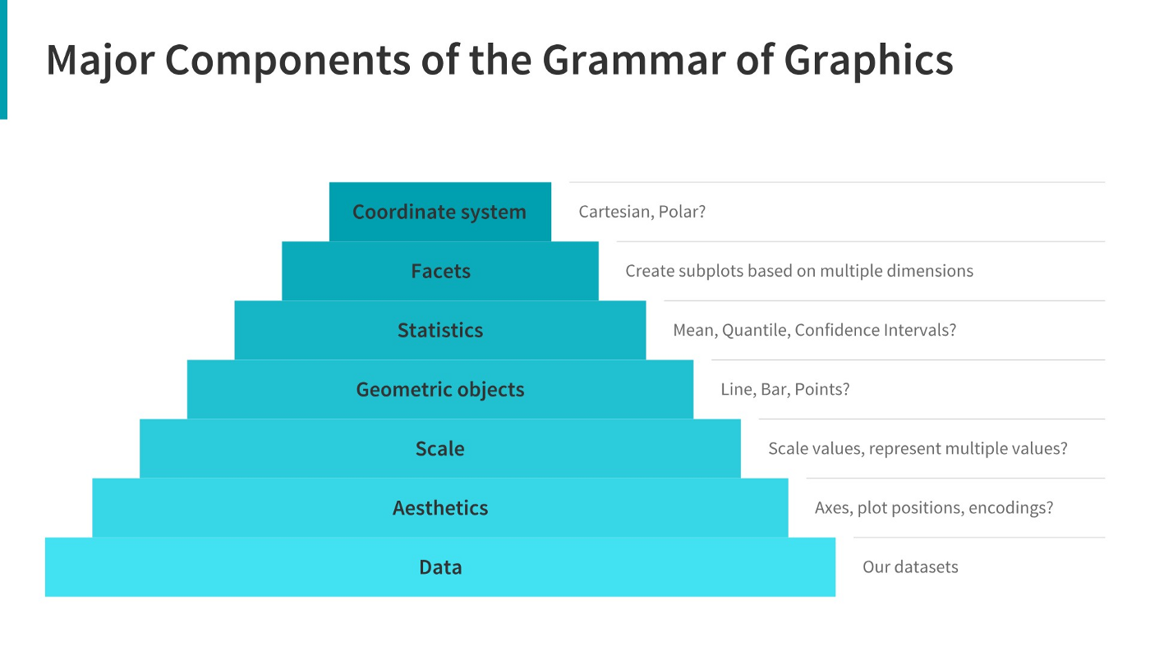

Choosing right charts based upon need such as Comparison, Distribution, Relationship, and Composition.
